***EXPERIMENT NO.2 BUFFERED AND SCANNER***

Program:-

import java.io.FileReader;

import java.io.BufferedReader;

class Userinputs

{

public static void main(String args[])

{

char[]array=new char[100];

try

{

FileReader file=new

FileReader("input.txt");

BufferedReader input=new

BufferedReader(file);

input.read(array);

System.out.println("Data in the file:");

System.out.println(array);

input.close();

}

catch(Exception e)

{

e.getStackTrace();

}

}

}

OUTPUT:-

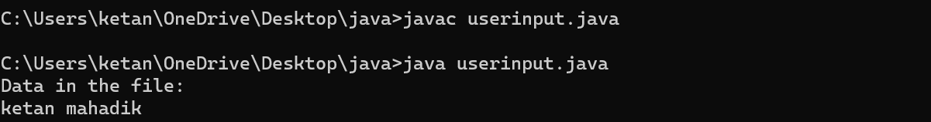

import java.util.Scanner;

public class array

{

public static void main(String args[])

{

int n;

Scanner sc=new Scanner(System.in);

System.out.println("Enter the number of the element you want to store: ");

n=sc.nextInt();

int[] array = new int[10];

System.out.println("Enter the element of the array:");

for(int i=0;i<n;i++)

{

array[i]=sc.nextInt();

}

System.out.println("Array element are:" );

for(int i=0;i<n;i++)

{

System.out.println(array[i]);

}

}

}

